Group 7

Sprint 2- Accuracy Design Document

November 24, 2020
Table of Contents
1. Executive Summary 2
1.1 Project Overview 2
1.2 Purpose and Scope of this Specification 2
2. Product/Service Description 2
2.1 Product Context 2
2.2 User Characteristics 2
2.3 Assumptions 2
2.4 Constraints 3
2.5 Dependencies 3
3. Requirements 3
3.1 Functional Requirements 4
3.2 Security 4
3.2.1 Protection 4
3.2.2 Authorization and Authentication 5
3.3 Portability 5
4. Requirements Confirmation/Stakeholder sign-off 5
5. System Design 6
5.1 Algorithm 6
5.2 System Flow 7
5.3 Software 8
5.4 Hardware 8
5.5 Test Plan 8
5.6 Task List/Gantt Chart 9
5.7 Block Code 9
5.8 Sensor Data 9
5.9 Staffing Plan 10

Executive Summary

Project Overview
This product is intended to test the Accuracy and capabilities of the Sphero SPRK+. By doing this, the product will help better our precision movements with this future endeavors.

Purpose and Scope of this Specification
In scope
- All testing was performed on a smooth surface to ensure the reliability of the movement feedback.
- All testing was performed without the case on the product to keep consistent in all movements.
- All testing was performed in a controlled environment to mitigate outside interference.

Out of Scope
- Do not use the product in wet environments as it may lead to mechanical failure.
- To ensure authenticity of robotic movements, keep the product on smooth surfaces.
- Do not incorporate any drops over 6 inches in the product’s path.

Product/Service Description
The Sphero SPRK+ spherical robot is programmed through coding functions. This product was developed by a small group of individuals. It was also developed over virtual interaction with only one individual having physical access to the product. This product had to pass a series of movements, color changes, and collision avoidance tests during this testing phase.

Product Context
This product is designed in a spherical shape and is programmed through coding. It is currently in the Accuracy phase, which focuses on precise maneuverability and multiple color changes. Once this phase is complete, it will have one more rigorous phase to follow. The product interfaces with the ‘Sphero’ application which can be accessed on mobile device or PCs.

User Characteristics
The intended audience ranges from inexperienced to intermediate level consumers:
- General User/Programming Beginner
- Technical Experience: 0-2 Years
- Age group: 8+
- Profession: Any
- Must have a stable internet connection and a passion for technology

Assumptions
- Mobile Android devices must have the following: Bluetooth LE (4.0), Android 5.0 or higher, Wi-Fi/Cellular capabilities, Gyroscope, Accelerometer, and a microphone.
- Mobile IOS devices can only use iPad 4+, iPad Mini 2, iPhone 5+, iPod Touch 6th gen+.
- Supports Windows 10 and macOS 10.12+

Constraints
- Limited gathering during global pandemic
- Technological incompatibilities
- All individuals involved with the product are on different schedules
- Materials not constructed to be able to survive drops and wet environments
- Creation of the course in which the product must complete

Dependencies
- This new product will require an internet connection to download the ‘Sphero’ application as well as a Bluetooth connection to connect to your product
- Test plan needs to be created before testing

Requirements
- Users must complete a Requirements table that includes what needs to be done and its priority. Individuals then must provide their signature for the agreed upon requirements.
- Creation of a ‘Staffing Plan’ should occur to give the appropriate roles to members in order to maximize efficiency
- Users must create a Gantt chart which will be a living document until the completion of the product.
This outlines projected timelines, actual time completed, flowcharts, algorithms, plans for testing and is the overall outline for completion of this product in its entirety.
- Users must create a block code for the requirements for the product and annotate each new function in a ‘Test Table.’ This will include specific projected actions with the actual outcome.
- Once the block code is extracted from the Sensor Data Diagram is successful, users must take that information and convert it into an algorithm. Once the algorithm is complete, they will convert it into a flow chart.
- Users will create a System Design Document that compiles all the above information
- The robot will have to stop, start, change colors, and change directions depending on the expected outcome of the testing

Priority Definitions
- Priority 1:
- Follow specified lighting configurations upon start/stop
- Such as finishing with multicolored lights flashing
- Follow specified speech considerations upon finish
- Such as saying “I am the winner” upon completion
- Finish the circuit in the designated space that it started
- Remain in the provided path
- Should complete its figure eight pattern 5 times
- Priority 2:
- SPRK+ should not collide with anything that would cause it to stray from the path
- Should take no longer than 5 minutes for completion of course
- Product should not change any colors or have any s
- Priority 3:
- The application to program the robot must be downloaded via internet. It would be nice if the application had a web-based GUI instead.
- The SPRK+ is limited to a 100ft blue range. It would be nice if there were a longer distance that could be covered to increase capabilities

Functional Requirements

Req# | Requirement | Comments | Priority | Date Rvwd | SME Reviewed / Approved
KRATOS_01 | Multiple colors when finished | Product must change multiple colors upon completion | 1 | 11/24/20 | Neal R.
KRATOS_02 | Speak “I am the winner” when finished | Product must say this phrase at the end of the of course | 1 | 11/24/20 | Neal R.
KRATOS_03 | Product must finish the course where it started | Product must finish the course where it started | 1 | 11/24/20 | Neal R.
KRATOS_04 | Complete the figure eight pattern 5 times | Product should loop a figure eight pattern 5 times | 1 | 11/24/20 | Neal R.
KRATOS_05 | No Collisions that would cause the robot to stray from the path | Product must complete the course without colliding with objects | 2 | 11/24/20 | Neal R.
KRATOS_06 | 5 minutes or less for completion | Product should complete the course in 5 minutes or less | 2 | 11/24/20 | Neal R.
KRATOS_07 | No changing colors or having any speech until completion | Product should not change colors or speak until the last step | 2 | 11/24/20 | Neal R.
KRATOS_08 | Limitations for distance may hinder performance | It would be nice if the product’s Bluetooth connection was not limited to 100ft. | 3 | 11/24/20 | Neal R.
KRATOS_09 | Accessibility Issues may limit potential | It would be helpful if the product’s application could be used offline | 3 | 11/24/20 | Neal R.

Security

Protection
Specify the factors that will protect the system from malicious or accidental access, modification, disclosure, destruction, or misuse. For example:
- All code is installed via authentic firmware and software which can prevent against threat actors and viruses
- 3rd party penetration tests to try and spot any weak points in apps or other services which can help prevent unauthorized access points
- Data is periodically checked to ensure stored data is valid which helps verify data integrity
- All data is encrypted when in transit and at rest to ensure data integrity to ensure product secrets are not lost

Authorization and Authentication
- Services will be routed to DNS servers utilizing RADIUS to access the network that provides firmware and software.

Portability
- Product features a portable charging case with hand carry straps
- Bluetooth dependent
- 100% dependent on host programming
- Available in the following languages
  - Arabic
  - Chinese (Simplified)
  - Chinese (Traditional)
  - English
  - Finnish
  - French
  - German
  - Hebrew
  - Italian
  - Japanese
  - Korean
  - Norwegian Bokmål
  - Mexican Spanish
  - Spanish
  - Swedish
- Must use Windows 10 or macOS 10.12.+
- Android:
  - Must use Bluetooth LE (4.0), Android 5.0 or higher, WiFi/Cellular capabilities, Gyroscope, Accelerometer, and a microphone
- IOS:
  - iPad 4+, iPad Mini 2, iPhone 5+, iPod Touch 6th gen+.
- Product needs to be in an environment where Bluetooth is easy capable without interference

Requirements Confirmation/Stakeholder sign-off
Include documentation of the approval or confirmation of the requirements here. For example:
Meeting Date | Attendees (name and role) | Comments
11/24/20 | Neal Roche | Confirmed ALL
11/24/20 | Jason Schray | Confirmed ALL
11/24/20 | Aaron Nitzberg | Confirmed ALL

System Design

Algorithm
- This is the algorithm used to program our product to run its figure eight pattern.
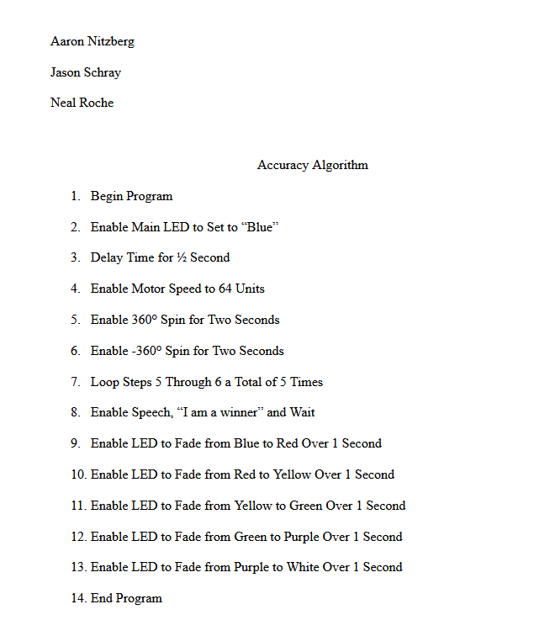

System Flow
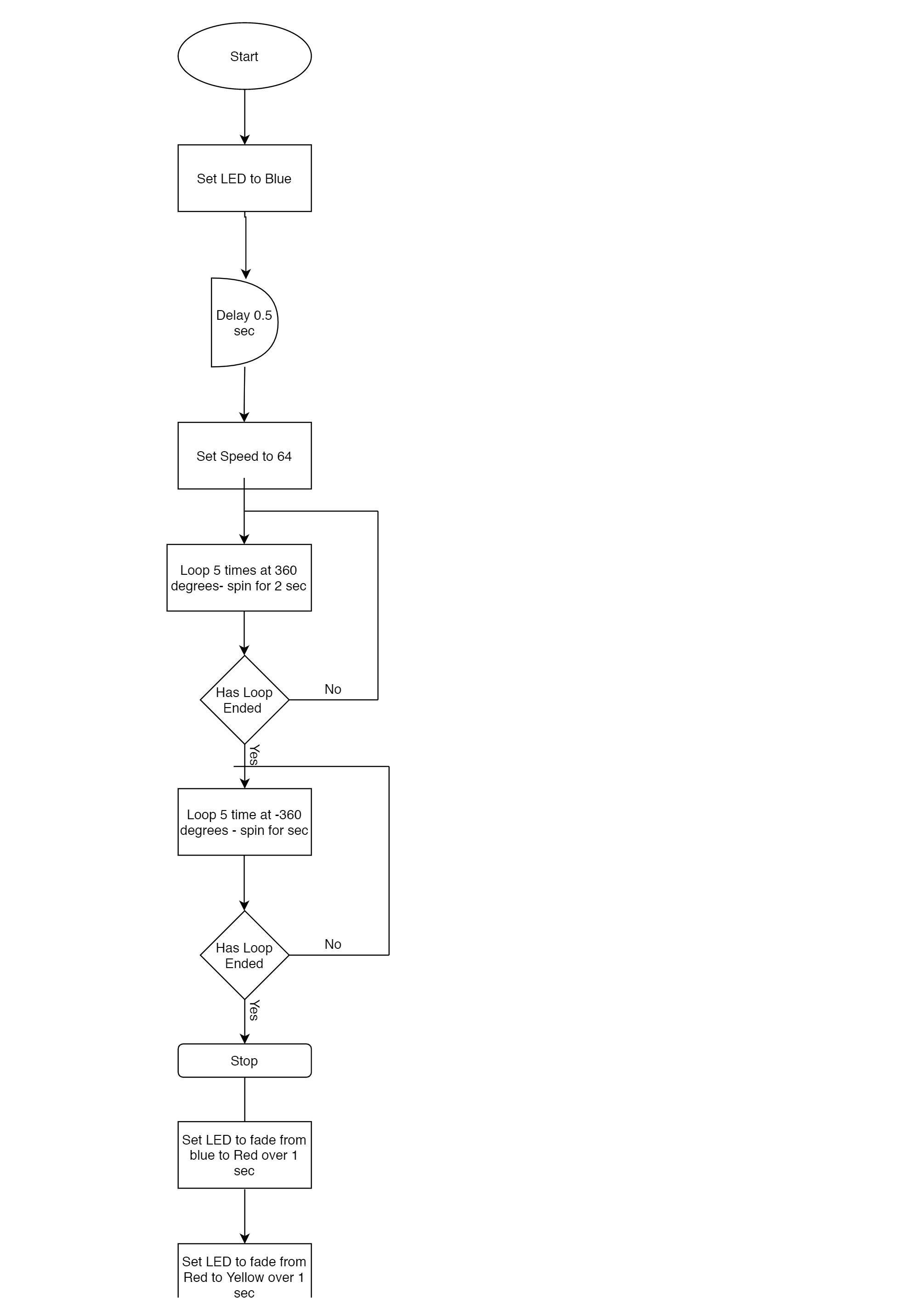

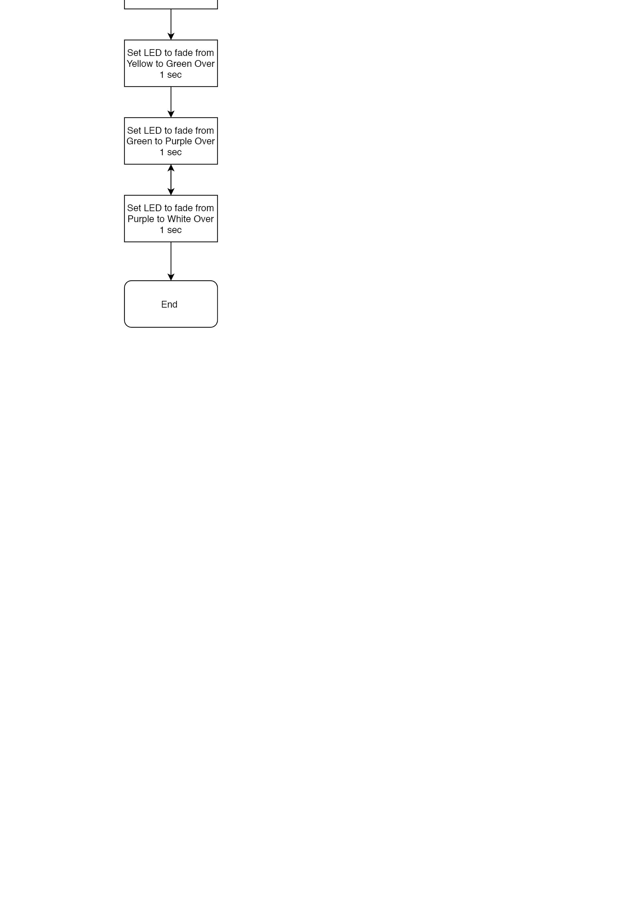

Software
- This product was created on a Windows 10 PC using Block Programming within the Sphero web application

Hardware
- Windows 10 HP PC was used to develop and test this product

Test Plan
Include a test plan showing all unit tests performed for this application, Include test rational, test date, staff member, pass/fail status

Reason for Test Case | Test Date | Expected Output | Observed Output | Staff Name | Pass/Fail
Confirm product moves forward | 11/24/20 | Product moves forward | Product moved forward | All team members | Pass
Confirm product move backward | 11/24/20 | Product moves backward | Product moved backward | All team members | Pass
Confirm product moves left/right | 11/24/20 | Product moves left/right | Product moved left/right | All team members | Pass
Color changes to multiple colors | 11/24/20 | Color changes multiple times | Color changed multiple times | All team members | Pass
Robot can execute 360-degree movements | 11/24/20 | Product executes 360 movements | Product executed 360 degree movements | All team members | Pass
Robot speaks “I am the winner” | 11/24/20 | Robot speaks “Ready, Set, Go” | Robot said “Ready, Set, Go” | All team members | Pass
Robot can stop | 11/24/20 | Robot stops | Robot stopped | All team members | Pass
Robot can repeat steps without hesistation | 11/24/20 | Robot completes steps without pausing | Robot performs loop successfully | All team members | Pass
Robot completes loop and ends at the start point | 11/24/20 | Robot ends loop at starting point | Robot does not end at start point. | All team members | Fail

Task List/Gantt Chart
- This chart defines our requirements as well as the timetable and percentage completed for each step.
- Group 7 Accuracy Gantt.xlsx

Block Code
- This is the actual code used to perform the movements needed to create a figure eight pattern.
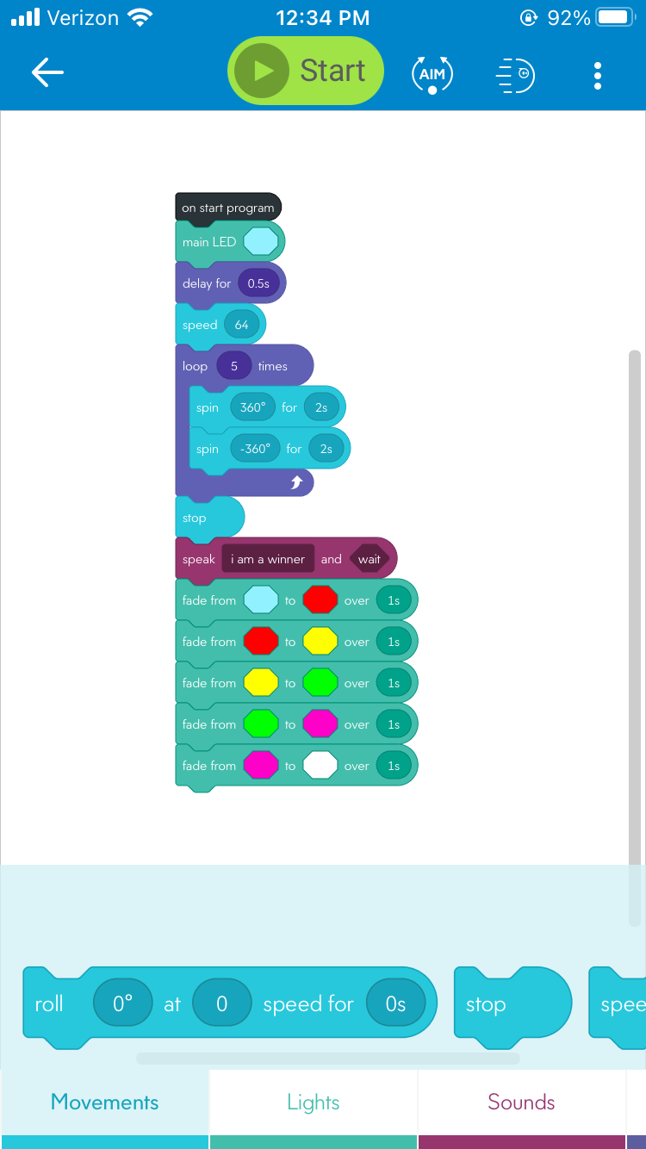

Sensor Data
- This is the sensor data regarding the movement. This is derived from the block code.
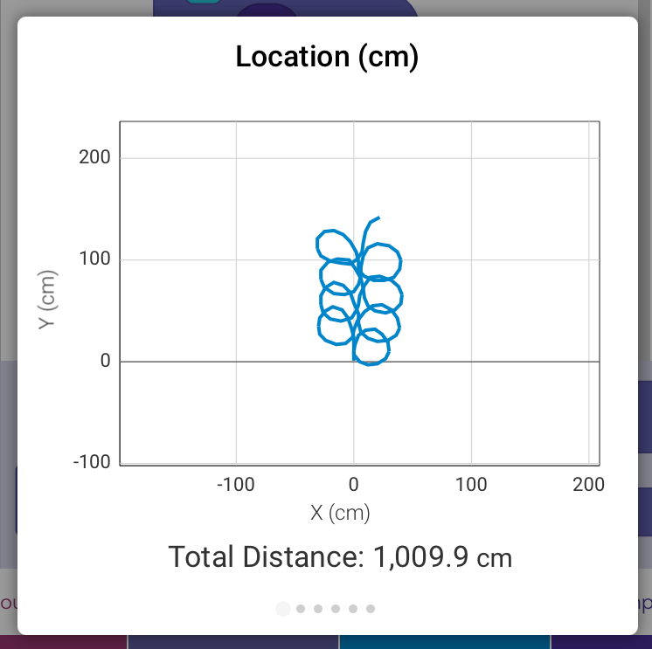

Staffing Plan
Insert a chart/table that depicts the roles and responsibilities of each team member that worked on this project

Name | Role | Responsibility | Reports To
Neal Roche | Group Leader | Plans tasks and schedules the work | The Group
Aaron Nitzberg | Robot System Designer | Designs the software for the robot | The Group/relays information for Jason to organize
Jason Schray | Information Organizer | Organizes results of tests provided through the design process | The Group/organizes the information that is relayed to Neal

